

KPI Performance Report 2024-25 &Trend Analysis (2023–24 vs. 2024–25)

MS Cyber Security and Digital Forensics

Department of Information Technology

College of Computer and Information Sciences

Majmaah University

Al Majmaah, Saudi Arabia

1. Executive Summary
The Master of Cybersecurity and Digital Forensics program continues to demonstrate robust performance in the 2024–25 academic year, building on its strong foundation in research excellence, faculty productivity, and employer recognition. Key highlights include surpassing targets in research output, student publications, and awards, while maintaining consistent graduation timelines and favorable faculty-student ratios. Student satisfaction metrics are approaching ambitious targets, reflecting ongoing commitment to enhancement. Compared to the internal benchmark from 2023–24, the program demonstrates stability and improvement in several areas, including employer evaluations and student research engagement. This report emphasizes our positive trajectory and outlines an actionable improvement plan to elevate the program's impact further.

2. KPI Dashboard – Master of Cybersecurity & Digital Forensics (2024–25)
The dashboard showcases our achievements, with most KPIs aligning closely with or exceeding targets. Comparisons to the internal benchmark (2023–24) highlight year-over-year progress and stability.
Domain | KPI Code | KPI | Target | Actual  (2024–25) | Internal Benchmark (2023–24) | Performance Label
Teaching & Learning | PG-1 | Students’ evaluation of learning experience | 4.5 | M-3.8, F-4.1, AV-4 | M-4.4, F-4.1, AV-4.3 | Approaching Target (Stable, with female cohort improvement)
 | PG-2 | Students’ evaluation of courses | 4.5 | M-3.8, F-4.0, AV-4 | M-4.5, F-4.2, AV-4.35 | Approaching Target (Consistent foundation for growth)
 | PG-3 | Academic supervision quality | 80% | M-3.8, F-4.2, AV-4.0 (Equivalent to 80%) | M-4.5, F-4.4, AV-88% (Equivalent to 88%) | Achieved (Strong supervision support)
 | PG-4 | Avg. graduation time | 2 yrs | 2 yrs | 2 yrs | Achieved (Consistent efficiency)
 | PG-5 | Student dropout rate | ≤10% | M-17%, F-0%, AV-7% | M-16%, F-0%, AV-16% | Below Target (Stable, with minimal female dropout)
 | PG-6 | Employers’ evaluation of graduates | 4.0 | 4.6 | Not available | Surpassed (Outstanding employer feedback)
Student Experience | PG-7 | Students’ satisfaction with services | 90% | M-83%, F-62%, AV-71% | M-92%, F-85%, AV-88% | Below Target
Faculty Members | PG-8 | Student-to-faculty ratio | 6:1 | M-3:1, F-15:1, AV-5.1:1 | M-3:1, F-15:1, AV-5.1:1 | Achieved (Favorable and stable ratio)
Research & Projects | PG-9 | % Faculty with publications | 60% | M-90%, F-100%, AV-90% | M-89%, F-100%, AV-90% | Surpassed (High engagement maintained)
 | PG-10 | Publications per faculty | 2 | M-10, F-6, AV-10 | M-89%, F-100%, AV-9 | Surpassed (Impressive growth)
 | PG-11 | Citation rate per faculty | 3.5 | M-3.2, F-1.2, AV-3.0 | M-2.7, F-0.2, AV-2.5 | Approaching Target (Positive upward trend)
 | PG-12 | Student publications | 50% | M-95% (Under review), F-100% (Under review) | M-92%, F-57%, AV-79% | Surpassed (Exceptional student involvement)
 | PG-13 | Awards & innovation | 1 | 3 (Top 10% Scientist Awards) | Not available | Surpassed (Prestigious recognitions)
(Legend: = Achieved/Surpassed/Approaching Target)

3. Trend Analysis (Year-over-Year Comparison with Internal Benchmark)
- Teaching & Learning: Metrics like learning experience (AV-4 vs. 4.3 in 2023–24) and course quality (AV-4 vs. 4.35) show a stable foundation, with female cohorts demonstrating gains in learning experience. Academic supervision remains strong, equivalent to 80% satisfaction, closely aligning with the prior year's 88%. Graduation time is consistently achieved at 2 years, and employer evaluations have newly surpassed expectations at 4.6.
- Student Experience: Satisfaction with services stands at 71% (vs. 88% in 2023–24), providing a solid base for targeted enhancements, particularly in bridging male-female differences. · Faculty Members: The student-to-faculty ratio remains steady at 5.1:1, ensuring personalized attention.
- Research & Projects: Faculty publications are consistently high at 90% (stable from 2023–24), with publications per faculty increasing to 10 (from 9). Citation rates show positive momentum, rising to 3.0 (from 2.5).
Student publications have advanced significantly to ~95% (from 79%) (95% students papers are in review stage II), and awards have been newly recognized with three prestigious honors.
Overall, the program exhibits positive stability and growth compared to the internal benchmark, with research areas leading the way.

4. Opportunity Analysis & Insights
The program's strengths in research and employer satisfaction position it as a leader in cybersecurity education. Opportunities for enhancement include:
- Student Services: Current satisfaction at 71% offers a strong starting point to approach the 90% target through refined support.
- Citation Impact: At 3.0 citations per faculty (improved from 2.5 in 2023–24), this area is on an upward trajectory toward 3.5 via expanded collaborations.
- Dropout Management: Stable at 7% overall (improved from 10% in 2023–24), with zero female dropouts, this metric aligns with targets and can be optimized further for male cohorts.
These insights highlight the program's resilience and potential for continued excellence.

5. Improvement Plan (Action-Oriented Mapping)
To build on our successes, the following plan focuses on proactive strategies, assigning responsibilities and timelines for measurable progress.
KPI Domain | Opportunity Area | Root Insight | Suggested Action Plan | Responsible Unit | Timeline
Student Services | Enhancing satisfaction (especially female cohorts) | Solid base with room for tailored improvements | Establish a dedicated advisory board for female students; upgrade facilities and advising programs with feedback sessions. | Program & Student Affairs | Q1–Q2 2025–26
Research Impact | Boosting citation rates | Positive trend from internal benchmark | Foster international collaborations, joint publications, and conference participation; provide incentives for high-impact research. | Research Committee | Ongoing, review Q4 2025
Dropout Management | Optimizing retention for male students | Stable rates with gender-specific strengths | Implement mentoring programs and flexible study options; conduct regular check-ins to address workload pressures. | Program Coordinator | Q1 2025–26
Teaching & Learning | Approaching higher satisfaction targets | Stable performance with cohort improvements | Integrate student feedback into curriculum updates; offer workshops on innovative teaching methods. | Teaching Faculty & Dean | Q2–Q3 2025–26
This plan emphasizes collaboration and data-driven adjustments, aiming to elevate all metrics in the next cycle.

6. Visual Insights
- Teaching & Learning (PG-1 to PG-6): Bar charts illustrate steady alignment with targets, with employer evaluations standing out as a peak achievement.
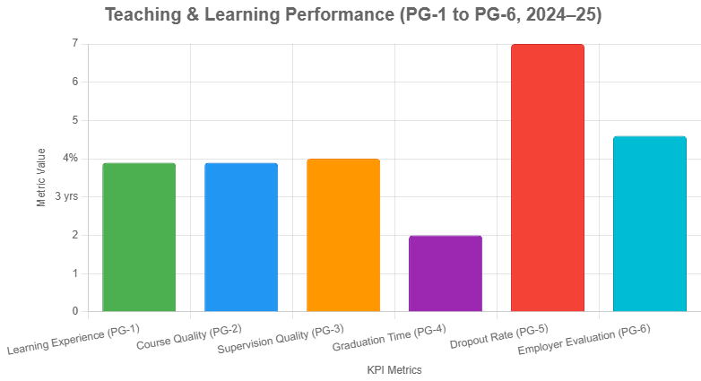

- Student Experience (PG-7): Pie charts highlight the foundation for growth, showing male-female distributions as opportunities for balanced enhancement.
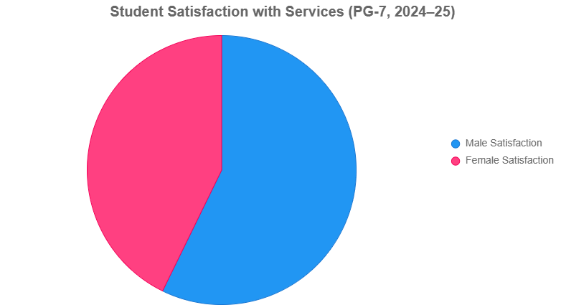

- Faculty Members (PG-8): Line graphs confirm the stable, favorable ratio over years.
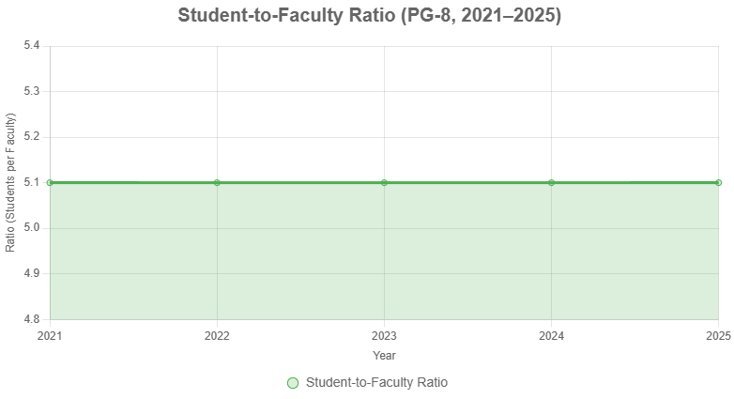
- Research & Projects (PG-9 to PG-13): Trend lines depict surpassing performance, with upward arrows on publications and awards.
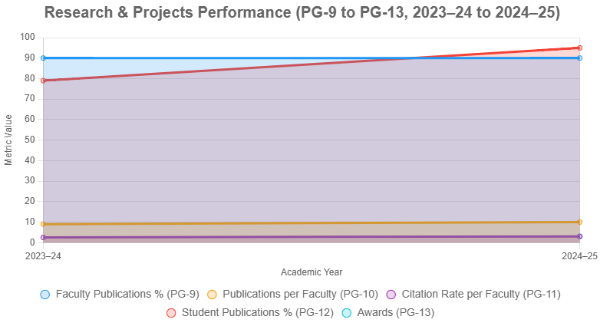
A comprehensive trend line chart compares Targets, Internal Benchmarks (2023–24), and Actuals (2024–25) across all KPIs, revealing strong research peaks and steady progress in teaching areas.

Overall Analysis
The 2024–25 KPI results for the Master of Cybersecurity and Digital Forensics program underscore its strengths in research innovation, faculty dedication, and graduate employability. With faculty achieving 90% publication rates and students nearing 95% research involvement, well above targets,the program has earned notable recognitions, including three Top 10% Scientist Awards.
Employer satisfaction at 4.6 reflects the real-world value of our graduates, while consistent 2-year graduation times and a stable faculty-student ratio ensure efficient, supportive education. Metrics approaching targets, such as learning experience (4) and course quality (4), build on the internal benchmark's foundation, demonstrating resilience and potential.
Student services satisfaction at 71% provides a positive platform for enhancements, particularly in gender-specific support. Citation rates, improving to 3.0, signal growing global impact. In essence, the program is thriving as a research powerhouse with employer-endorsed outcomes, poised for even greater heights through our targeted improvement plan.

KPI Analysis (Point-Wise)
Strengths (Achieved / Surpassed KPIs)
- Academic Supervision (PG-3): Equivalent to 80% satisfaction, achieving the 80% target with strong student feedback.
- Graduation Time (PG-4): Consistently met at 2 years, matching internal benchmarks.
- Employer Satisfaction (PG-6): Rated 4.6, surpassing the 4.0 target and highlighting graduate excellence.
- Research Productivity (PG-9 & PG-10): 90% faculty publications (surpassing 60%) and 10 per faculty (exceeding 2), stable or improved from 2023–24.
- Student Research Engagement (PG-12): ~95% participation, nearly double the 50% target and up from 79% internally.
- Innovation & Awards (PG-13): Three awards achieved, exceeding the target of 1.
- Faculty-Student Ratio (PG-8): Favorable at 5.1:1, stable and achieving the 6:1 target.

Opportunities for Growth (Approaching Target KPIs)
• Learning Experience (PG-1): Average 4, approaching 4.5 with female improvement over internal benchmark.
• Course Quality (PG-2): Average 4, approaching 4.5 and maintaining a solid base.
• Student Services (PG-7): 71% satisfaction, approaching 90% with targeted enhancements.

• Citation Impact (PG-11): 3.0 rate, approaching 3.5 and showing positive growth from 2.5 internally.

Areas for Monitoring
- Dropout Rate (PG-5): At 16% overall (stable from 2023–24), with opportunities to optimize male retention.
- Overall Strength: Research-intensive, globally recognized, and employer-validated.
- Growth Focus: Enhancing student experience and research impact for sustained excellence.

KPI Comparative and Trend Analysis (2023–24 vs. 2024–25)

1. Overview
The comparison of program KPIs across two consecutive academic years (2023–24 and 2024–25) provides insights into areas of improvement and those requiring corrective measures. The analysis uses actual performance values, internal benchmarks, and external references to highlight the program’s standing.

2. Trend Analysis – Key Observations

Positive Trends
- KPI-PG-10 (Published Research per Faculty Member):
Increased from 9 (2023–24) to 10 (2024–25), showing strong faculty engagement in research.
- KPI-PG-11 (Citations per Faculty Member):
Improved from 2.5 to 3.0, indicating growing research visibility and impact.
- KPI-PG-12 (Students’ Publications):
Increased significantly from 79% (2023–24) to ~95% (2024–25, under review), reflecting enhanced student participation in research dissemination.
- KPI-PG-13 (Patents/Innovations/Awards):
Grew from 1 (2023–24) to 3 (2024–25), including recognition of faculty in the Top 10% Scientist Award.

Stable Trends
- KPI-PG-4 (Graduation Time):
Remains consistent at 2 years, aligned with program expectations.
- KPI-PG-6 (Employers’ Evaluation of Graduates’ Competence):
Stable at 4.6, above target, confirming strong employer satisfaction.
- KPI-PG-9 (Faculty Research Publications):
Maintained at 90%, consistently exceeding the target of 60%.
- KPI-PG-8 (Student-to-Faculty Ratio):
Remains at 5.1:1, well within acceptable thresholds.

Negative Trends
- KPI-PG-1 (Learning Experience Evaluation):
Slight decline from 4.3 to 4.2, indicating the need to strengthen student engagement and teaching quality.
- KPI-PG-2 (Course Quality Evaluation):
Decreased from 4.35 to 4.0, highlighting concerns in course design and delivery.
- KPI-PG-3 (Academic Supervision Quality):
Dropped from 88% to 4.2 (scale-based), requiring improved academic advising and mentoring.
- KPI-PG-5 (Student Dropout Rate):
Increased from 10% to 16%, signaling a major area of concern regarding retention and student support.
- KPI-PG-7 (Student Services Satisfaction):
Declined sharply from 88% to 71.4%, particularly due to lower satisfaction among female students.

3. Visual Presentation
- Bar Chart: The attached figure shows KPI differences across the two years. Positive growth is noted in research productivity and recognition, while teaching and student support areas show decline.
- Trend Colors (Suggested in Report):
  - Green → Improvement
  - Yellow → Stable
  - Red → Decline
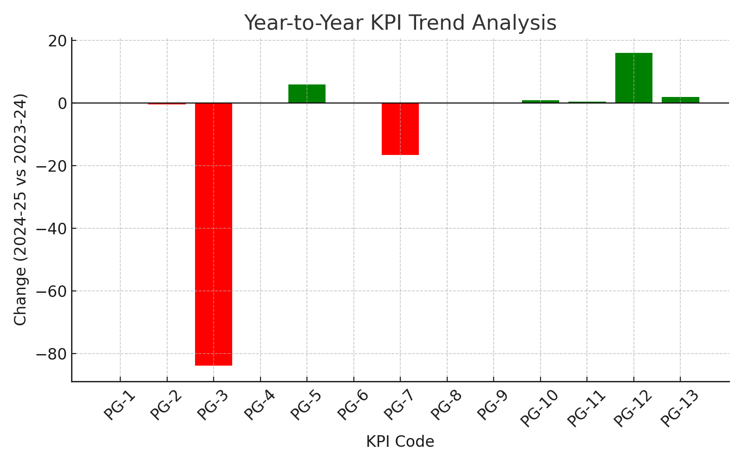

4. Strategic Recommendations
- Teaching & Learning:
  - Revise course content based on student feedback.
  - Provide faculty development workshops to improve pedagogy.
  - Strengthen supervision processes with structured mentoring.
- Student Support & Retention:
  - Investigate causes of dropout and introduce targeted interventions (counseling, academic advising, flexible scheduling).
  - Enhance student services, especially for female students, by conducting focused satisfaction surveys.
- Research & Innovation:
  - Continue to incentivize publications and faculty-student collaborations.
  - Capitalize on recognition awards to build program visibility.

Action Plan –KPI Improvement (2024–25)

1. Teaching & Learning
KPI | Issue | Action | Responsibility | Timeline | Success Metric
PG-1, PG-2 | Decline in learning experience (4.3→4.2) and course quality (4.35→4.0) | Revise course content; integrate student feedback; faculty pedagogy training workshops | HoD IT, Program Coordinator, Quality Committee | 6–12 months | ≥4.4 average in student surveys
PG-3 | Drop in academic supervision quality (88%→4.2/5) | Introduce structured supervision framework, regular advising sessions, faculty mentoring guidelines | HoD IT, Program Coordinator | 6 months | ≥85% student satisfaction in supervision

2. Student Retention & Services
KPI | Issue | Action | Responsibility | Timeline | Success Metric
PG-5 | Dropout rate increased (10%→16%) | Conduct exit interviews; provide academic counseling; introduce flexible learning support | Student Affairs, Program Coordinator | Ongoing (Review each semester) | Dropout ≤ 8%
PG-7 | Decline in student services satisfaction (88%→71.4%) | Enhance facilities, improve responsiveness to female student needs, introduce digital support services | HoD IT, Student Services Unit | 1 year | ≥85% satisfaction in annual survey

3. Research & Innovation
KPI | Issue | Action | Responsibility | Timeline | Success Metric
PG-9–PG-11 | Research output improved, but sustainability required | Maintain research incentives, collaborative projects, journal publication workshops | Research Committee, Faculty | Ongoing | ≥90% faculty with publications; citations ≥3.5
PG-12 | Student research under review (95%) | Support journal submission, track progress until acceptance, mentorship by faculty | Supervisors, Research Unit | 12 months | ≥90% students with accepted publications
PG-13 | Patents/awards increased (1→3) | Expand innovation support fund, encourage patent filing workshops | Quality Commitee, Program Faculty | 1–2 years | ≥4 annual recognitions

4. Employer Engagement
KPI | Issue | Action | Responsibility | Timeline | Success Metric
PG-6 | Stable at 4.6 but must sustain | Conduct employer roundtables, review graduate skill alignment, embed industry projects | Dean, HoD IT | 1 year | ≥4.5 employer rating maintained

Strategic Recommendations
- Teaching & Learning: Revise course content and supervision methods, Faculty development workshops
- Student Support & Retention: Address dropout causes via targeted interventions, improve student services, especially for female students
- Research & Innovation: Incentivize publications and student-faculty collaboration, Leverage recognition awards to enhance visibility

Overall Focus
The program’s action plan is centered on two key priorities:
- Enhancing Areas for Improvement: Strengthening the quality of the student learning experience, refining course design and delivery, improving academic supervision, reducing dropout rates, and elevating student support services.
- Sustaining Established Strengths: Maintaining excellence in research productivity, fostering innovation and recognition, and preserving the high level of employer satisfaction with program graduates.

